Put your website online

1. Introduction
It's cool to know how to make great websites... But what's the point if there's no one to admire them?

This resource is an introduction to putting a website online, with lots of good links to do so.

2. History
There is a lot to say about how the internet works and the protocols. At the end of this resource, we have attached some videos if you want to learn more.
For now, here are some readings to understand DNS and what happens when you type google.com in your browser:
- Vlad Gerasimov made a comic explaining the basics of DNS in a simple way.
- dnsimple have made a comic as well explaining the principle of DNS.

3. The course
For the moment, your site is only on your personal computer. To put it online, 2 steps are necessary:
- Host your code somewhere. It is usually possible to do this via the service that sells domain names.
- Get a domain name (to have sites like www.tonsite.com) and then make it redirect to the place where your code is hosted. This requires a DNS connection to the service that sells you the domain name.

3.1. Host your website on a service

As mentioned above, most domain name companies also offer to host your code. This is an easy solution because it requires only a few DNS connections. Indeed, everything is on the same platform!

3.2. Buy a domain name
Now, to buy a domain name, you can go through :
- OVH, one of the few French unicorns, which offers a domain name purchase service. They also offer to host code in a simple and inexpensive way.
- Gandi, which is also a leader in domain names
- 1and1, which offers the purchase of domain names, with very easy and cheap hosting.

3.3. Free code uploading services
If you want to put your site online without having to buy a domain name, this list of services offering simple code upload will be useful:
- The most famous: GitHub Pages. This service of GitHub proposes to each of its users to host their code on the net. To do so, you just have to go to the settings of one of your repo, to the Github Pages section, and then assign a source (usually, master branch). It's as simple as that. It's also very often the personal site of any self-respecting tech. Here are some resources to learn how to master GitHub Pages :
  - MicrowaveSam made a video explaining how to plug in GitHub Pages. He even goes as far as explaining CDN connections to assign a custom domain name to your site.
- There is also Surge, a great service to quickly upload your own files.

🚀 GOOD TIP
A website (that I really like) that allows you to see what your page looks like online is RawGit (replaced by RawGitHack). You can paste the GitHub url of the index.html file and have a preview that you can share with the whole world :) Send your sites to your friends ! It's a very convenient site to share a page easily and have a feeling of power.
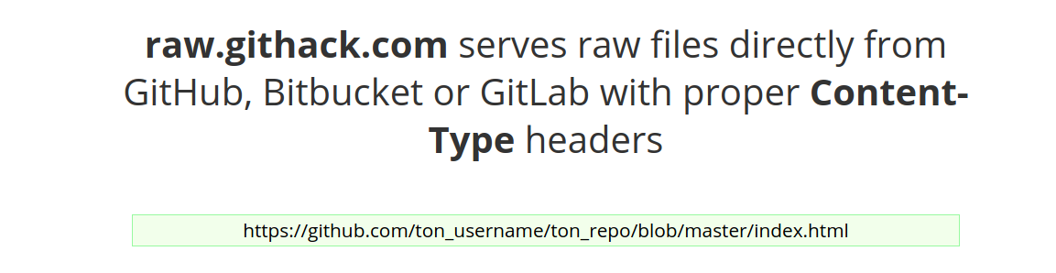

4. To recap
Let’s sum up:
- To have a site online, you need to host your code and buy a domain name. Most domain name vendors offer simple code hosting. OVH is an inexpensive and convenient solution that gets the job done.
- There are code uploading services that also offer you to have an accessible online version of your site. GitHub Pages is one of the most famous and reputable.

5. To go further

The fantastic CS50 course has made an introduction to the HTTP world, available on Youtube. This 1h40 lecture will explain you the world of HTTP/WWW/TCP/etc.

